

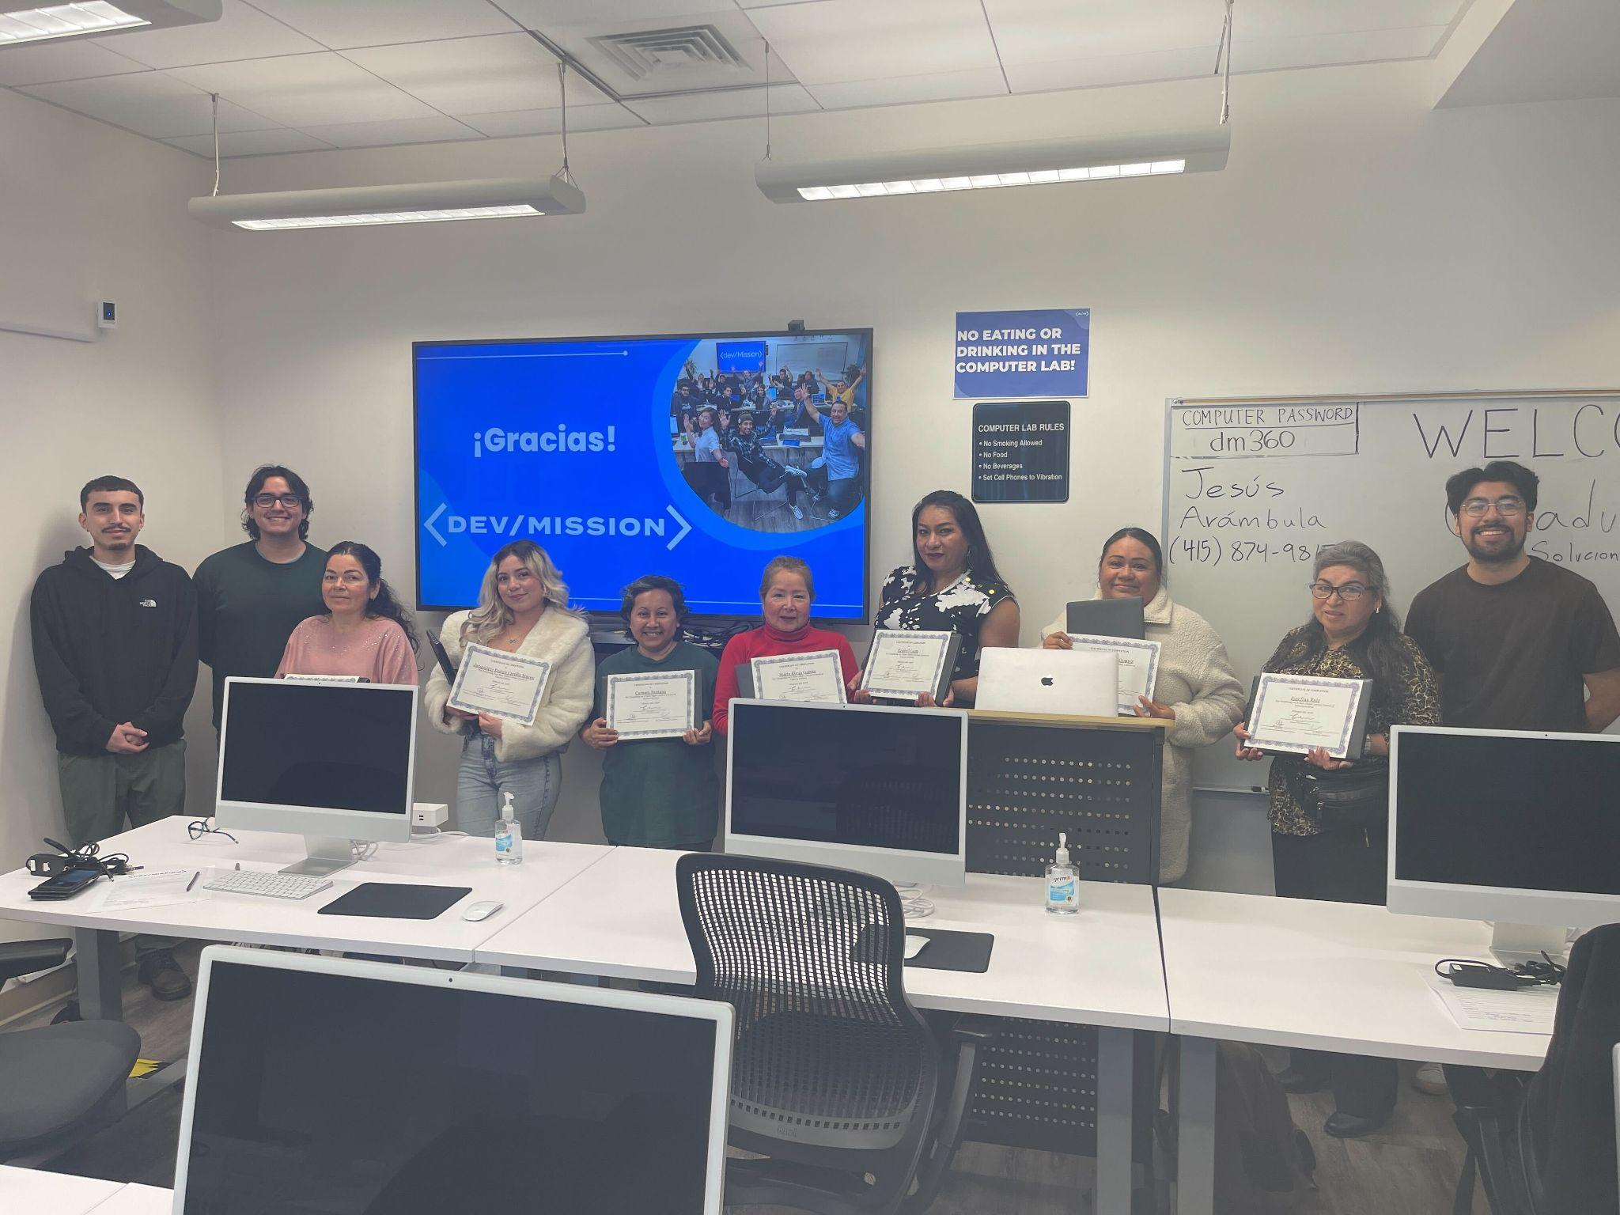
(Season Year Spanish Digital Literacy Graduation Day Cohort Cohort Number)

Season Year Spanish Basic Digital Literacy - Summary Program Report
Start - End, Year

360 Valencia Gardens
360 Valencia Street
SF, CA 94103

Funded by
CPUC & AT&T

DEV/MISSION

Jesus Arambula | - | Instructor
Leonardo Sosa | - | Executive Director
Isaac Sosa | - | Refurbishing Center Program Coordinator

TABLE OF CONTENTS
TABLE OF CONTENTS 2

1. PROGRAM OVERVIEW 3

2. RECRUITMENT 4

3. SPONSORS 5

4. STUDENT PROFILES 6

5. PROGRAM CURRICULUM 7

6. PROGRAM OBJECTIVES 10

7. ACTIVITIES 10

8. CHALLENGES 10

9. PROGRAM PHOTOS AND VIDEOS 11

1. PROGRAM OVERVIEW

This grant significantly enhances the Community Technology Ambassador program by amplifying resources dedicated to intensive digital literacy education tailored specifically for public housing and low-income communities. In addition to this educational initiative, the grant facilitates the distribution of laptop computers among these underserved groups, ensuring broader access to essential technology.

The program is structured to cover fundamental computer skills, internet usage, online safety, communication tools, and productivity software. Our approach integrates classroom-style training with hands-on practical sessions, providing all participants with a comprehensive and immersive learning experience.

Furthermore, the development of a robust outreach strategy is integral to the program's success. We are committed to engaging individuals within these communities by raising awareness through community events, workshops, local media collaborations, and strategic partnerships with community leaders and organizations. By fostering these connections and disseminating information widely, we aim to ensure that those who stand to benefit most are well-informed and encouraged to participate in the program actively.

2. RECRUITMENT

The recruitment for the digital literacy workshop was entrusted to the Dev/Mission Creative Team, which created the flyers and invitations for the Basic Digital Literacy Workshops and distributed flyers as part of its efforts to attract participants. Participants were reached out to confirm their attendance and participation via phone calls.

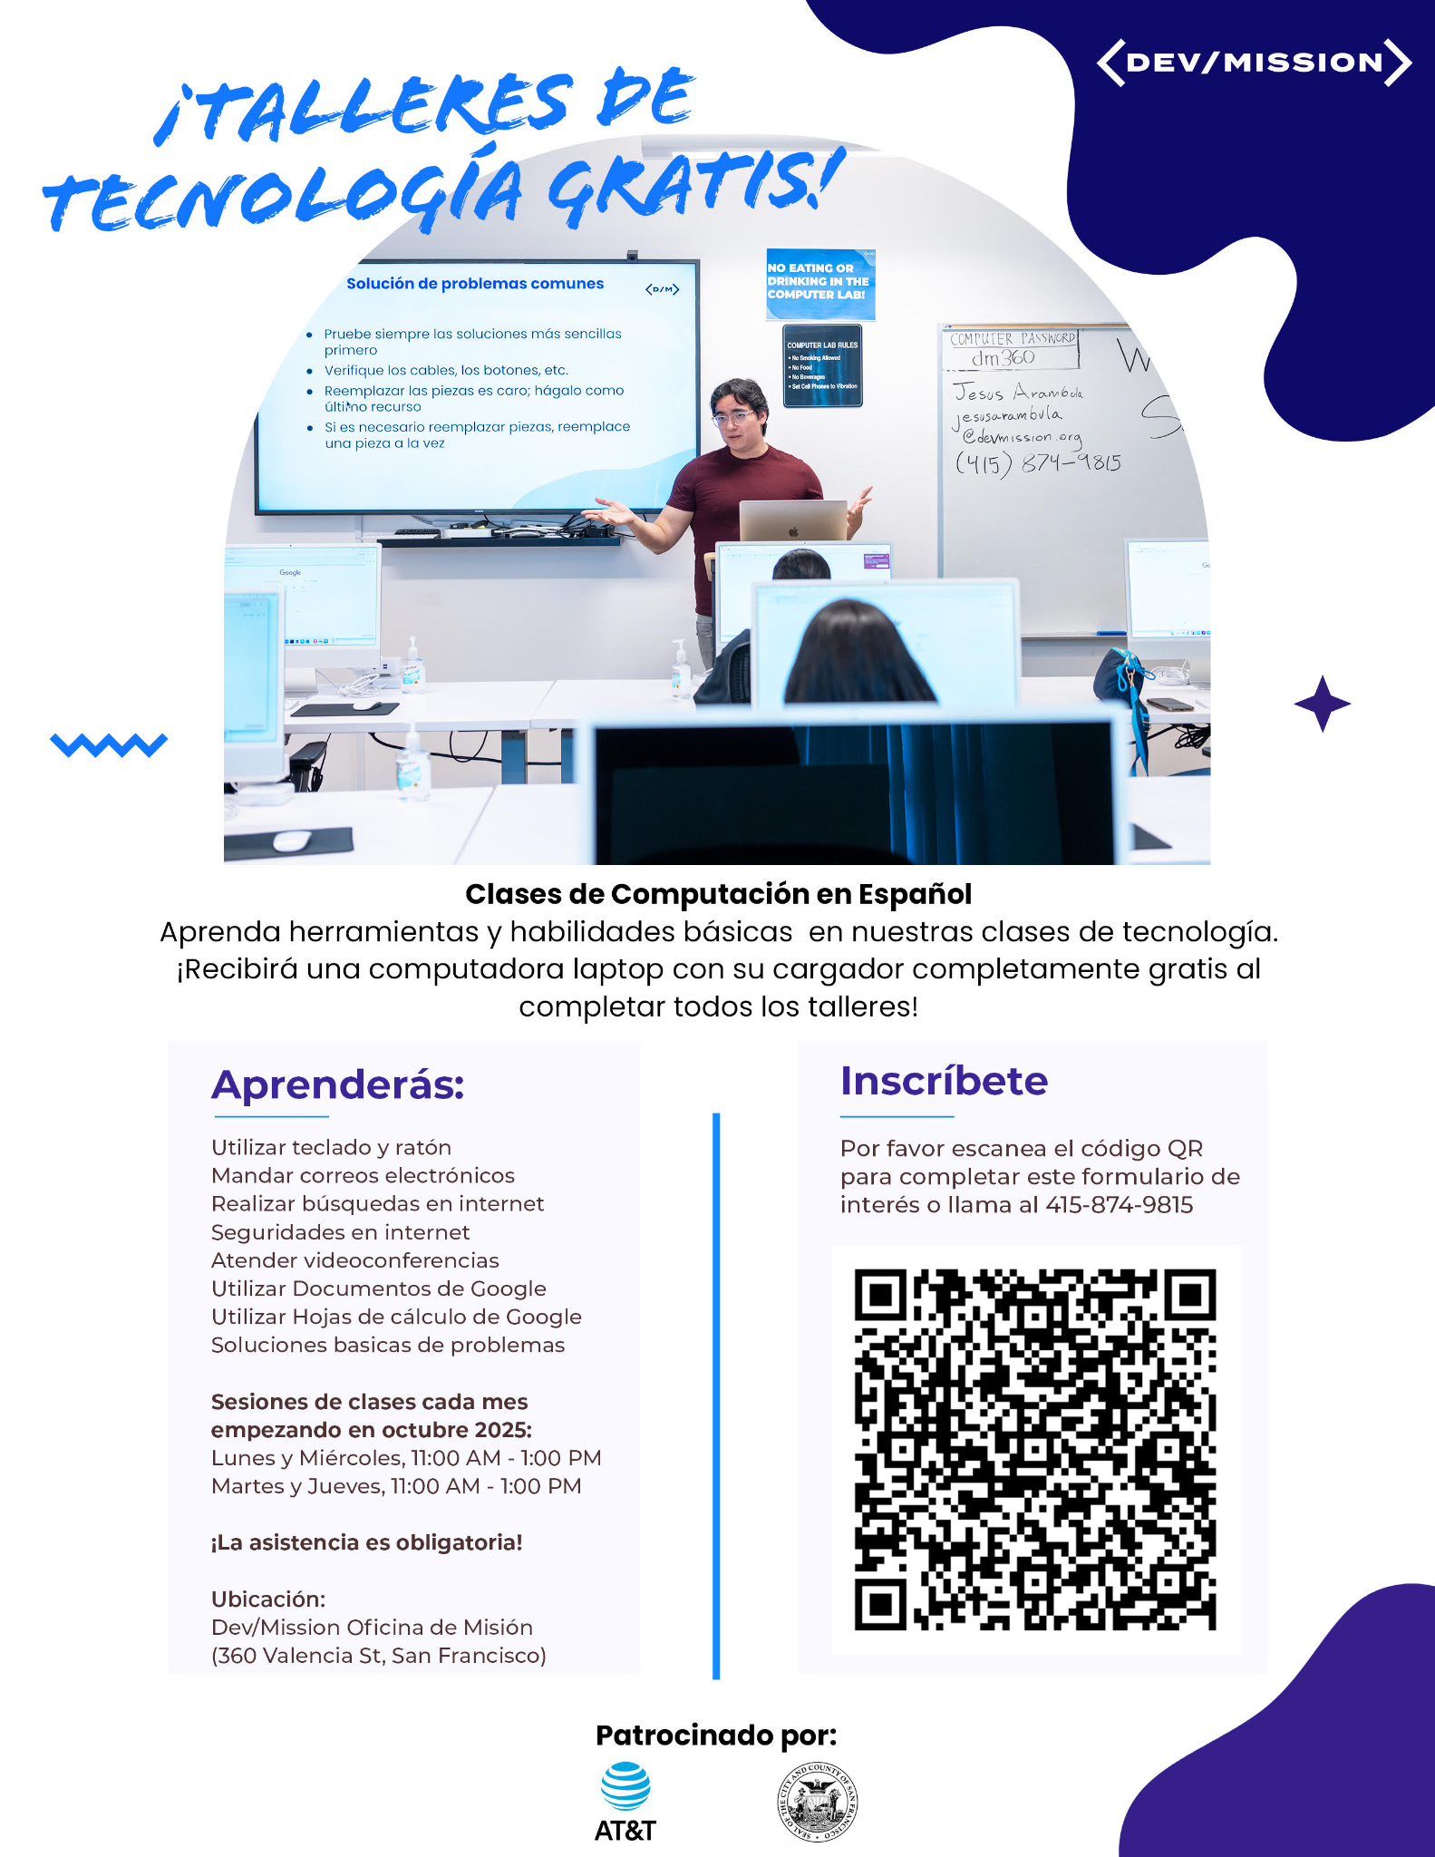

3. SPONSORS

Dev/Mission is deeply grateful to the following sponsors for their generous financial backing. Providing the essential resources to bring this program to life and offering their support and dedication to our mission.



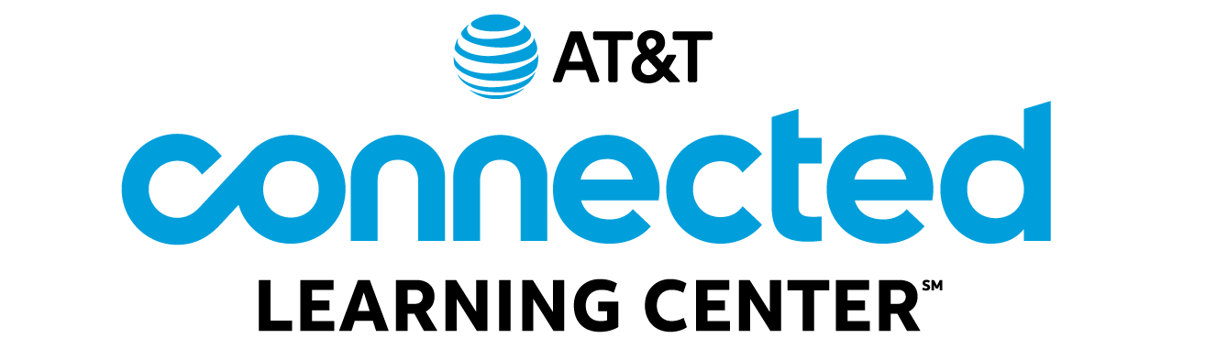



4. STUDENT PROFILES


Image by Clker-Free-Vector-Images from Pixabay

The students ranged between the ages of 22 - 67. The racial classification of the group was 9 Latina Females. Our focus of recruitment is those who live in underserved communities.
The group of adults came from the following districts in SF:
◦ Excelsior District ◦ Hayes Valley ◦ Inner Mission/Bernal Heights ◦ Nob Hill ◦ Outer Mission ◦
◦ Bayview-Hunters Point ◦ South of Market ◦
Age | Gender | City | Zip Code | Status
48 | Female | San Francisco | 94109 | Graduated
59 | Female | San Francisco | 94112 | Graduated
44 | Female | San Francisco | 94110 | Graduated
23 | Female | San Francisco | 94110 | Graduated
53 | Female | San Francisco | 94134 | Graduated
67 | Female | San Francisco | 94134 | Graduated
22 | Female | San Francisco | 94109 | Graduated
46 | Female | San Francisco | 94103 | Graduated
27 | Female | San Francisco | 94112 | Dropped

5. PROGRAM CURRICULUM

At the end of our four-week digital literacy workshops, we're thrilled to give each participant a free refurbished laptop. These engaging sessions, which last two hours each, are held twice a week on Mondays and Wednesdays. We focus on empowering individuals with crucial digital skills.

Our workshops cover everything from basic keyboard and mouse operations to effectively navigating the Internet, mastering Gmail, video conferencing etiquette, and utilizing Google Docs and Sheets. We also discuss troubleshooting common technical issues and emphasize internet safety practices to ensure a secure online experience.

The best part of our program is giving each person a device when they finish. Learning should be more than just knowing things; it's about using what you learn. By providing laptops, we help people practice their new skills and stay connected in today's digital world.

We're dedicated to teaching digital skills and ensuring everyone can use what they learn. Our goal is to help each person succeed in a world that relies increasingly on technology.

Image by vectorjuice on Freepik

Workshop 1: Keyboard/Mouse

This course is designed to help individuals develop fundamental skills in using a computer mouse and keyboard effectively. Whether you're a complete beginner or looking to improve your existing skills, this course will provide step-by-step guidance and hands-on practice to help you become proficient in these essential input devices.

Workshop 2: Email Basics
This course is designed to provide individuals with a solid foundation in email communication, focusing on Gmail as a widely used email platform. Whether you're new to email or looking to enhance your Gmail proficiency, this course will guide you through the essentials of sending, receiving, organizing, and managing emails effectively.

Workshop 3: Performing Internet Searches

This course is designed to equip individuals with the skills and techniques needed to perform effective and efficient online searches. Whether you're a novice internet user or looking to refine your search abilities, this course will provide you with the tools and strategies to find information quickly and accurately on the internet.

Workshop 4: Security Awareness

This course is designed to educate individuals on the importance of security in the digital age and provide them with the knowledge and skills to protect themselves and their organizations from cyber threats. This course covers various aspects of security, from online privacy to data protection, and aims to create security-conscious individuals.

Workshop 5: Video Conferencing
This course is designed to help individuals become proficient in using the Zoom platform for virtual meetings, webinars, and online collaboration. Whether you're new to Zoom or looking to enhance your skills, this course will provide step-by-step guidance on how to effectively host and participate in Zoom meetings.

Workshop 6: Google Docs/Drive

This course is designed to equip individuals with comprehensive knowledge and practical skills for creating, editing, and collaborating on documents using Google Docs. Whether you're new to Google Docs or looking to enhance your proficiency, this course will guide you through the essential features and functionalities of this popular cloud-based word processing application.

Workshop 7: Google Spreadsheets

The Google Sheets Proficiency course is designed to provide individuals with the knowledge and practical skills required to effectively use Google Sheets for data analysis, management, and collaboration. Whether you're new to spreadsheets or looking to enhance your skills, this course will guide you through the essential features and functionalities of Google Sheets.

Workshop 8: Basic troubleshooting

This course is designed to equip individuals with fundamental problem-solving techniques and troubleshooting strategies applicable to various aspects of technology and everyday situations. This course will empower participants to identify and resolve common issues effectively.

6. PROGRAM CURRICULUM

Training Area | Date | Topic | Description | Hours | Facilitator
Spanish Digital Literacy  Day1-Day2  11:00 AM - 1:00 PM | Date1 | Mouse/Keyboard/Typing | Introduction to using keyboard + Mouse | 2 | Jesus Arambula
Spanish Digital Literacy  Day1-Day2  11:00 AM - 1:00 PM | Date2 | Email/Gmail | How to use Email + Gmail | 2 | Jesus Arambula
Spanish Digital Literacy  Day1-Day2  11:00 AM - 1:00 PM | Date3 | Performing Internet Searches | Learn how to use a Browser & Search Engine for Internet searches | 2 | Jesus Arambula
Spanish Digital Literacy  Day1-Day2  11:00 AM - 1:00 PM | Date4 | Security Awareness | Learn how to use and browse the internet + safety protocols safely | 2 | Jesus Arambula
Spanish Digital Literacy  Day1-Day2  11:00 AM - 1:00 PM | Date5 | Videoconferencing | How to use Zoom | 2 | Jesus Arambula
Spanish Digital Literacy  Day1-Day2  11:00 AM - 1:00 PM | Date6 | Google Docs | How to use Google Docs | 2 | Jesus Arambula
Spanish Digital Literacy  Day1-Day2  11:00 AM - 1:00 PM | Date7 | Google Sheets | How to use Google Sheets | 2 | Jesus Arambula
Spanish Digital Literacy  Day1-Day2  11:00 AM - 1:00 PM | Date8 | Basic Troubleshooting | Hardware components, Intro to BIOS & POST, Solving common problems | 2 | Jesus Arambula
Total Hours |  |  |  | 16

7. PROGRAM OBJECTIVES

Empower clients with essential digital skills through Dev/Mission's Digital Literacy Workshops. The program aims to enhance participants' competencies in email communication, video conferencing, internet searches, word processing, Excel spreadsheets, security awareness, and basic troubleshooting. The program's success in enhancing participants' digital literacy will be assessed through a systematic measurement of skills acquisition. This evaluation will be conducted via client survey feedback, providing valuable insights into the effectiveness of the Digital Literacy workshop.

8. ACTIVITIES
- Combination of lectures, online tools, and small activities to enhance skills
- Mouse exercise on online-platform “ratoneando”
- Exercise on online-platform w/ typing.com
- Kahoot Quiz (As an IceBreaker)
- Phishing Test Exercise with Jigsaw.com
- Hands on experience with Google Docs
- Hands on experience with Google Sheets
- Hands on experience with Zoom app
- Hands on experience with Gmail

9. CHALLENGES

- Punctuality: We found punctuality to be a significant challenge. Many clients often struggled to arrive on time due to personal and family reasons. Although this tardiness was an issue for the class attendance, the main content the students missed was the Kahoot quiz at the beginning of each workshop. Students arrived before the main workshop content was delivered and paid attention in class.
- Holiday: For the month of January, Monday January 19th was Martin Luther King day, which results in this class graduating a week after the workshops were meant to be finished.
- Time: During the workshops, some of the participants expressed concerns that the allocated workshop duration of two hours was insufficient to fully grasp the workshop material. They felt that the limited time made it challenging to cover complex topics comprehensively, engage in meaningful discussions, and clarify their doubts effectively. To address these concerns, the instructor occasionally recommended scheduling meetings with CTA (Community Technology Ambassador) to review topics, providing participants with an opportunity to revisit and reinforce their understanding for increased comfort and proficiency.

10. Program photos

